**DOCKER FILE ATTRIBUTES**

A **Dockerfile** is a script that contains instructions for building a Docker image. Each instruction represents a step in the process, and many of these steps include attributes or options.

**Dockerfile instructions and their attributes:**

**1. FROM:** Specifies the base image to use for the build.

* **Syntax:** FROM <image>[:<tag>] [AS <name>]

**2. RUN:** Executes a command during the build process.

* **Syntax:** RUN <command>
  + Example: RUN apt-get update && apt-get install -y curl

**3. CMD:** Specifies the default command to run when the container starts.

* **Syntax:** CMD ["executable", "param1", "param2"]

**4. ENTRYPOINT:** Specifies the main command to run in the container.

* **Syntax:** ENTRYPOINT ["executable", "param1", "param2"]

**5. COPY:** Copies files/directories from the build context to the image.

* **Syntax:** COPY [--chown=<user>:<group>] <src> <dest>

**6. ADD:** Similar to COPY but with additional capabilities:

* **Syntax:** ADD [--chown=<user>:<group>] <src> <dest>

**7. WORKDIR:** Sets the working directory for subsequent instructions.

* **Syntax**:WORKDIR <path>

**8. ENV:** Sets environment variables.

* **Syntax:** ENV <key>=<value> [<key>=<value>...]

**9. EXPOSE:** Indicates the ports the container listens on.

* **Syntax:** EXPOSE <port> [<port>...]

**10. VOLUME:** Defines a mount point for storing data that persists outside the container.

* **Syntax:** VOLUME ["<path>"]

**13. LABEL:** Adds metadata to the image.

* **Syntax:** LABEL <key>=<value> [<key>=<value>...]

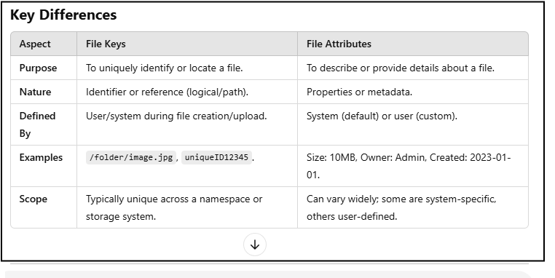

Create EC2 instance, deployed Docker and added ec2 user into Docker group.

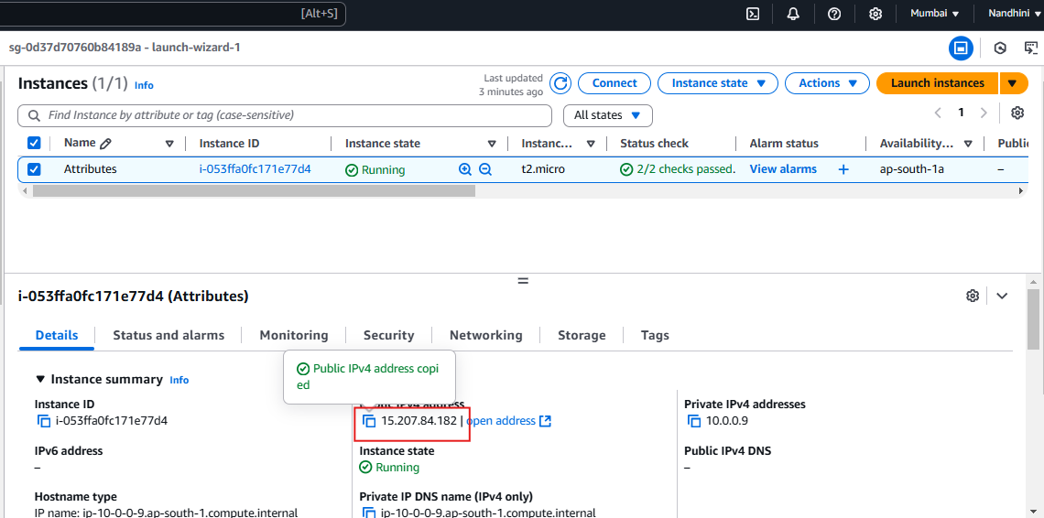

Created Docker file and entered commands to build a customized image using File Attributes.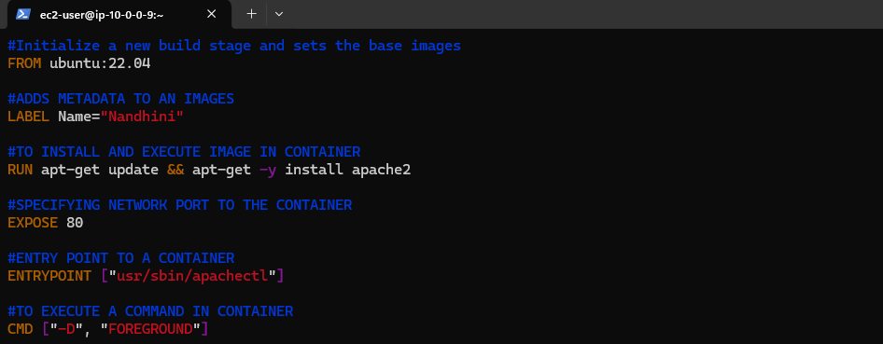

Used Docker Inspect to view LABEL details.

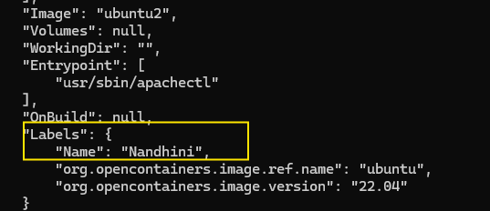

Created image and container using Docker file.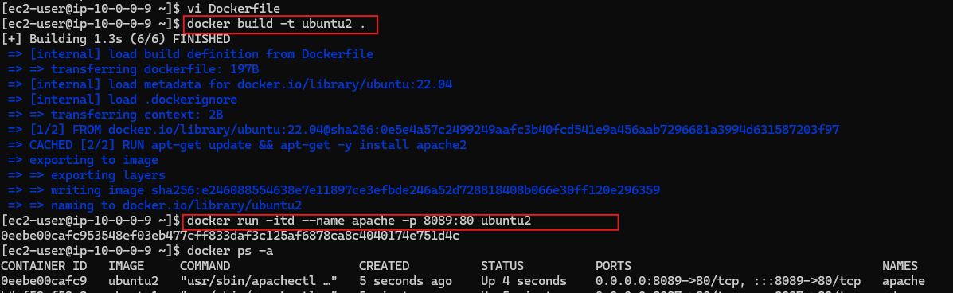

Edited inbound rule to allow port no: 8089 to access image.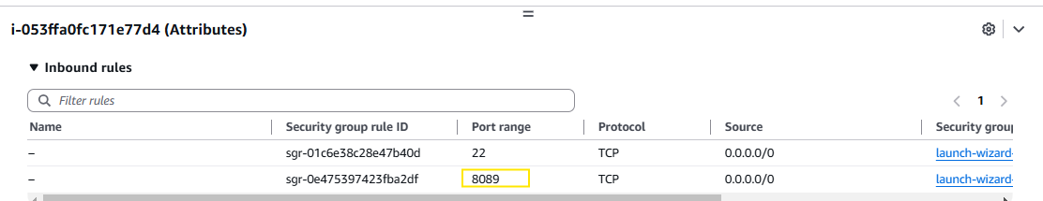

Accessed Apache web server.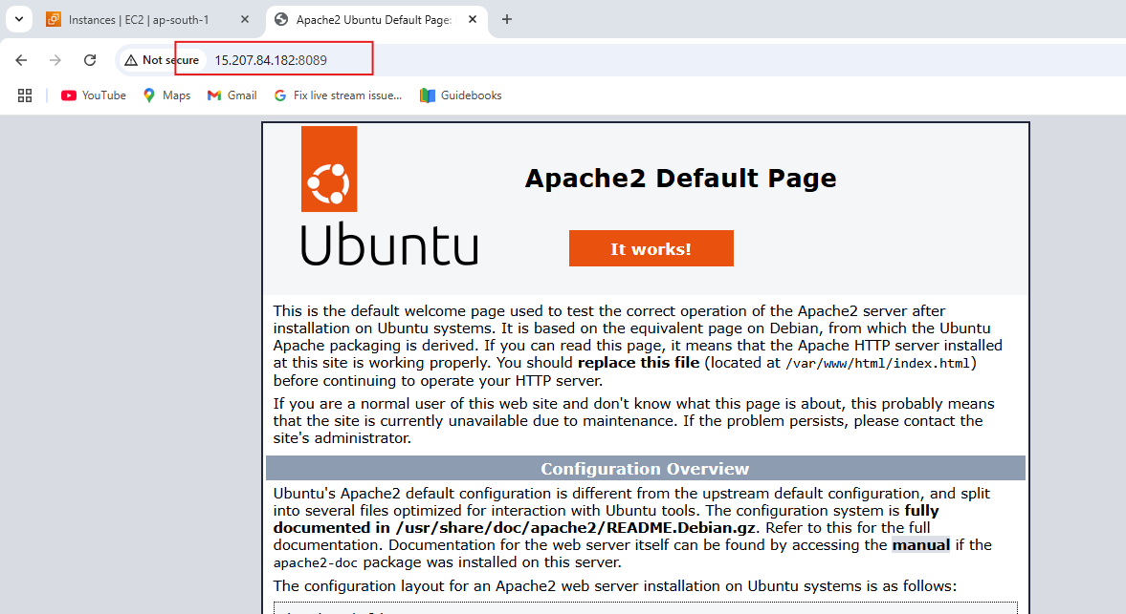

Created one more index file to perform COPY attribute.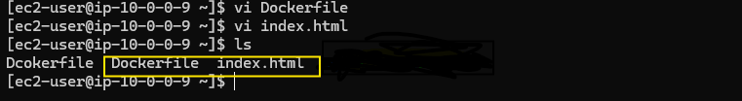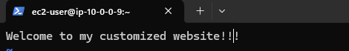

Using COPY attribute copying file from host to container.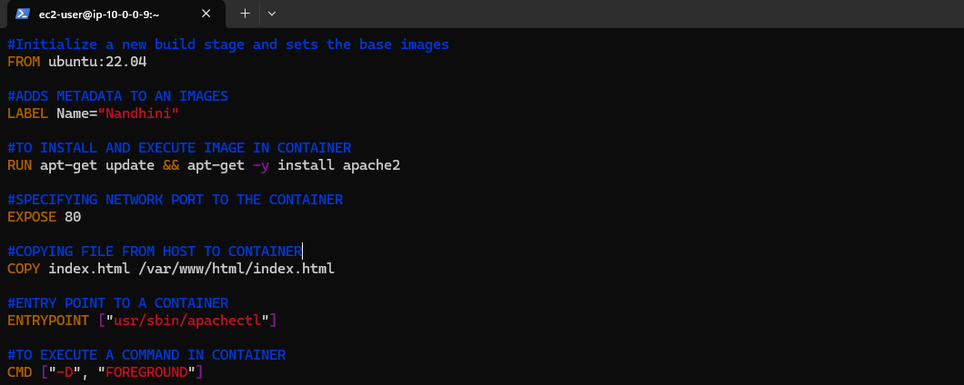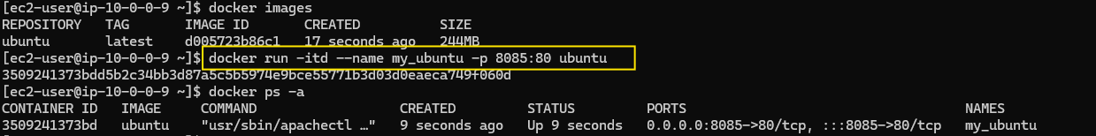

Edited inbound to allow port no: 8085 to access customized image.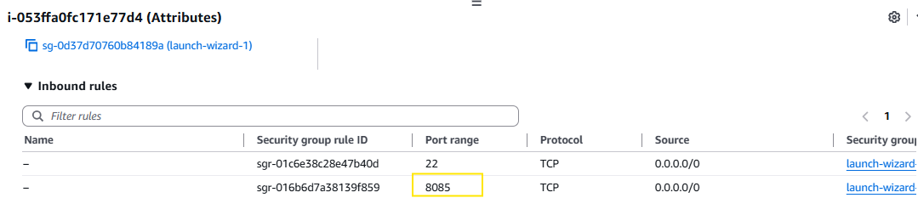

Accessed customized image.

